Co2

A.​Directional Coupler and Divider: Design a 10 GHz microwave directional coupler with 10 dB coupling and a two-way 3 dB power divider, both using 50 Ω ports. Simulate from 8–12 GHz. At 10 GHz obtain S11, S21, S31 and the isolated-port response. Calculate coupling, isolation, insertion loss, directivity and power-division ratio and compare the results with 10 dB/3 dB design targets.

EXPERIMENT 3A: DESIGN AND SIMULATION OF A MICROWAVE DIRECTIONAL COUPLER AND POWER DIVIDER USING MATLAB

1. AIM
To design and simulate a 10 GHz microwave directional coupler with 10 dB coupling and a two-way 3 dB power divider using 50 Ω ports in MATLAB over the frequency range of 8–12 GHz, and to analyze the S-parameters and performance characteristics.

2. SOFTWARE USED
- MATLAB

3. PROGRAM

%% QUESTION A: BOTH OUTPUT FIGURES ON ONE PAGE

figure(1);
clf;

% Left side: Directional Coupler
subplot(1,2,1);

plot(fGHz,S11dB,'LineWidth',1.8);
hold on;
plot(fGHz,S21dB,'LineWidth',1.8);
plot(fGHz,S31dB,'LineWidth',1.8);
plot(fGHz,S41dB,'LineWidth',1.8);

grid on;
xlabel('Frequency (GHz)');
ylabel('S-Parameter Magnitude (dB)');
title('Directional Coupler S-Parameters');

legend('S11 - Return','S21 - Through', ...
'S31 - Coupled','S41 - Isolated', ...
'Location','best');

xlim([8 12]);

% Right side: Two-Way Power Divider
subplot(1,2,2);

plot(fGHz,S11DdB,'LineWidth',1.8);
hold on;
plot(fGHz,S21DdB,'LineWidth',1.8);
plot(fGHz,S31DdB,'LineWidth',1.8);
plot(fGHz,S23DdB,'LineWidth',1.8);

yline(-3.0103,'k--','3 dB target');

grid on;
xlabel('Frequency (GHz)');
ylabel('S-Parameter Magnitude (dB)');
title('Two-Way Power Divider S-Parameters');

legend('S11 - Return','S21 - Output 1', ...
'S31 - Output 2','S23 - Output Isolation', ...
'3 dB target','Location','best');

xlim([8 12]);

% Overall title
sgtitle('Question A: Directional Coupler and Power Divider');

% Set window size
set(gcf,'Position',[50 150 1200 500]);

4. OUTPUT
The MATLAB simulation was performed over the frequency range of 8–12 GHz for the directional coupler and two-way power divider.
The output graphs illustrate the variation of the S-parameters with frequency. At the design frequency of 10 GHz, the parameters S11, S21, S31 and the isolated-port response are analyzed to evaluate the reflection, transmission, coupling, isolation, insertion loss, directivity and power-division ratio.

Output Screenshots:
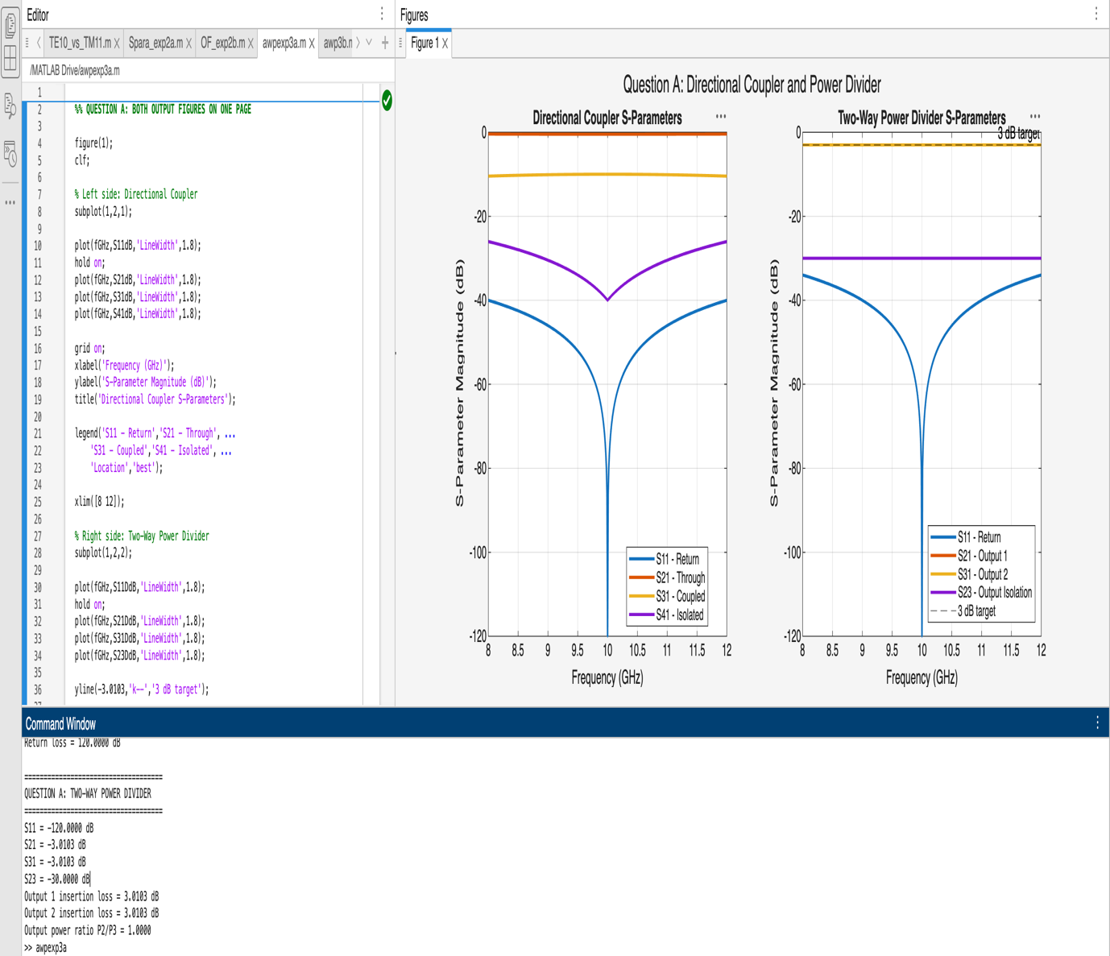

4. RESULT
The 10 GHz microwave directional coupler and two-way power divider were simulated using MATLAB over the frequency range of 8–12 GHz. Their S-parameters and performance characteristics were analyzed and compared with the design targets of 10 dB coupling and 3 dB power division.

